Tickets In Pega

Ticket is a process rule which is been used to jump in a flow from one shape to another shape.

In any of an assignment shape we can go down and see a tickets option.

If we click on any flow shape we have a facility to call tickets.

If we call ticket in the end shape then work object will jump from assignment shape to end shape

Ticket must be set anywhere in the workflow

In order to set ticket we call an OOTB activity “Set-Tickets”

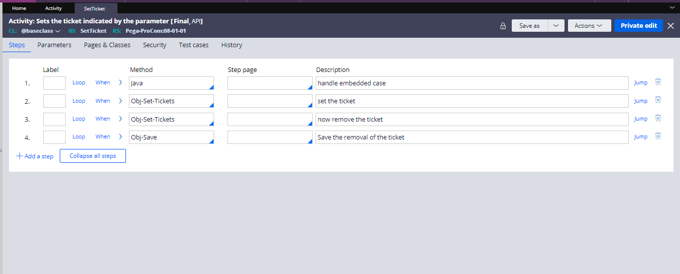

Once we fire this activity the work object will check where the ticket is called wherever the ticket is called work-object is going to jump.

In programming we use the goTo statements

In order to jump we need to set the ticket with help of OOTB Activity

Create a ticket under process > ticket

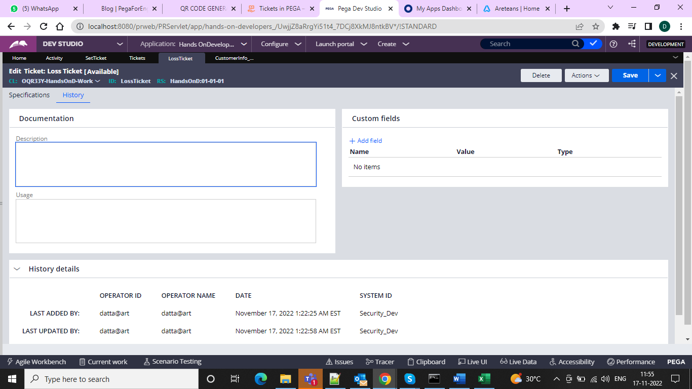

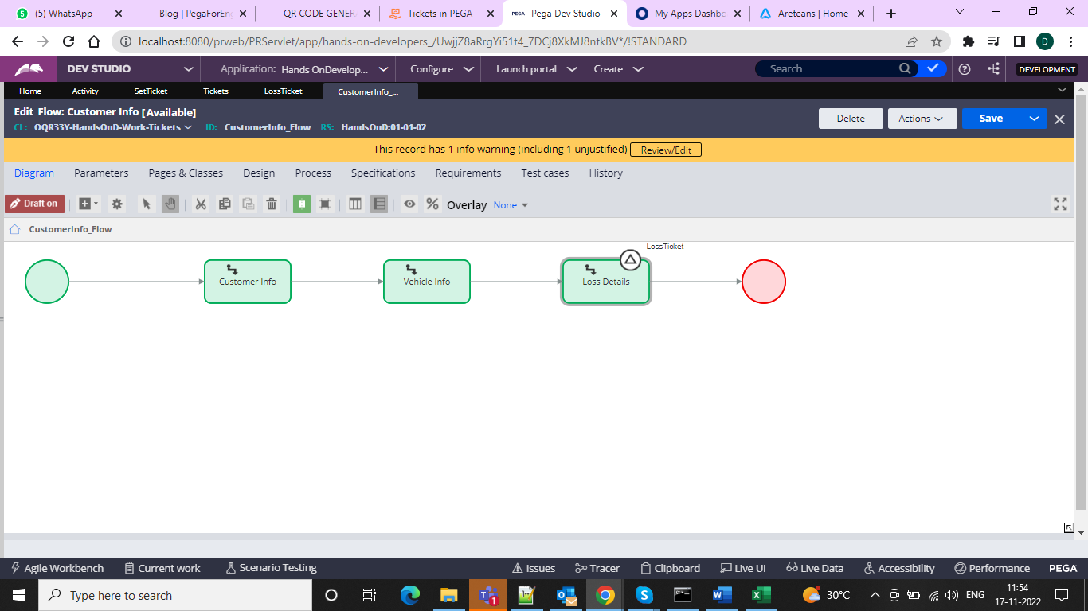

And after this we can configure utility to jump based on vehicle new or old

To update status we have an OOTB to use which is UpdateStatus

And after this configure the activity we need to call the Set Call SeticketStatus and then we need to do as below

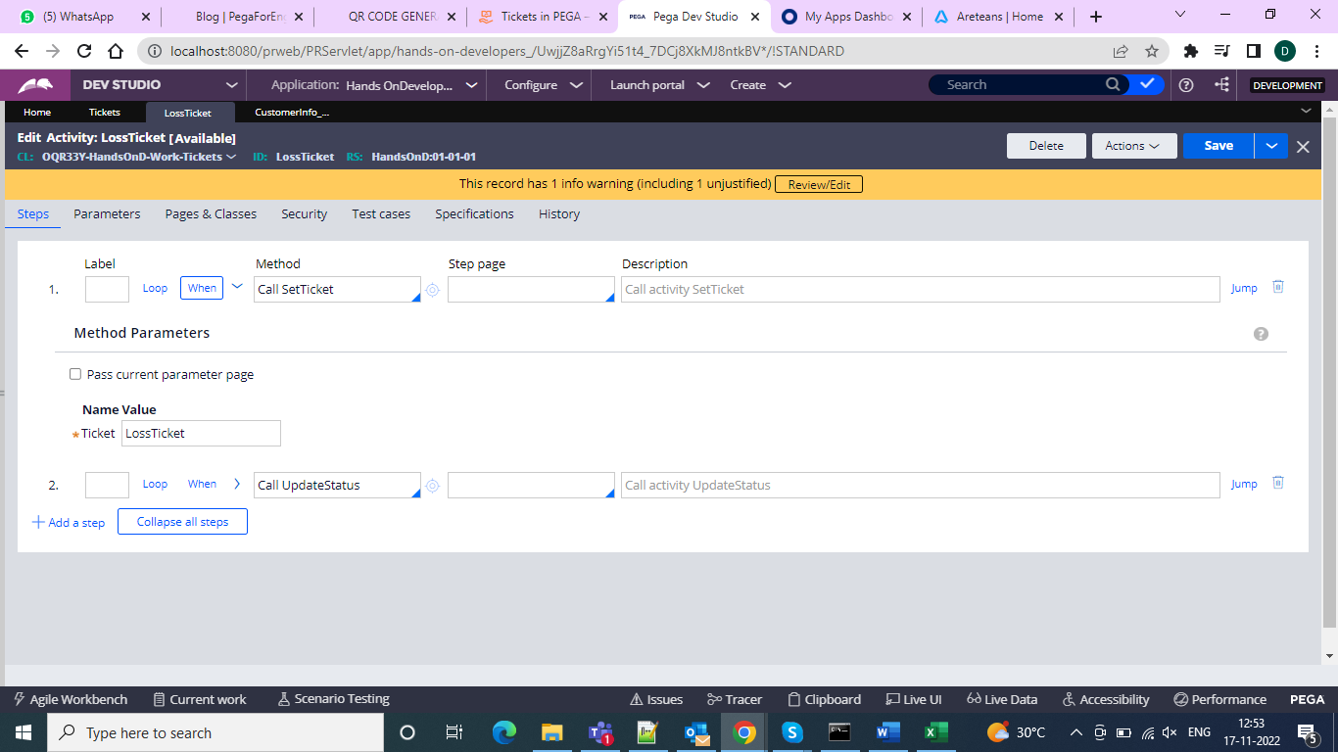

And when condition as to how it has to execute

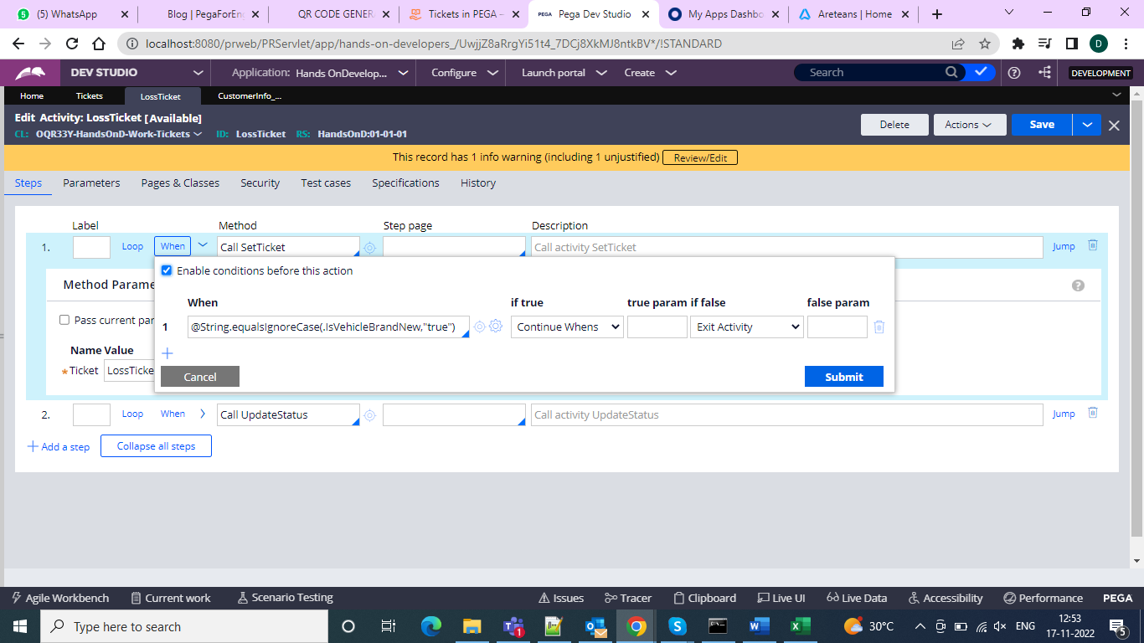

And in order to update status

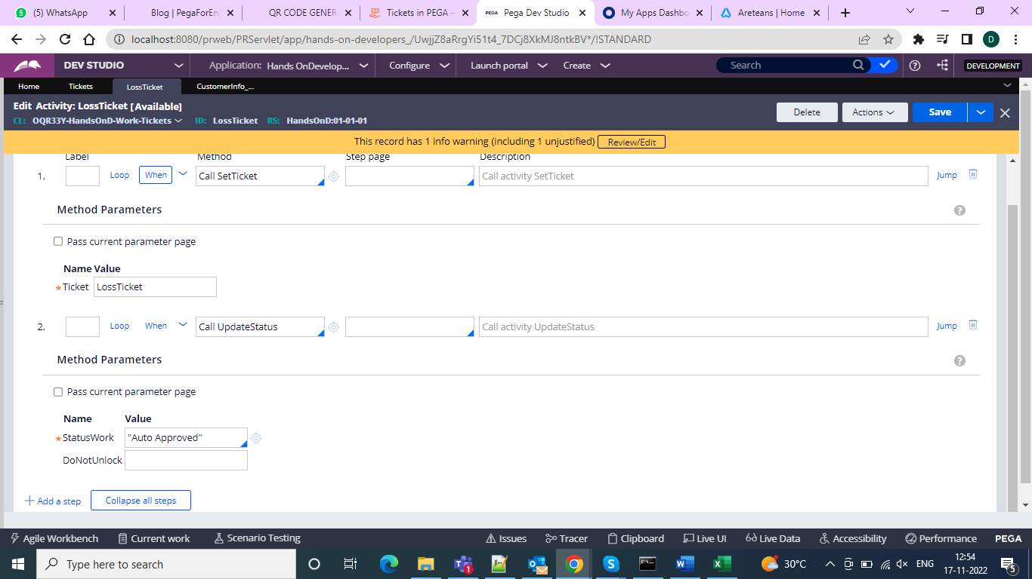

And now when we run the case as not selected brand new it will go to the vehicle info since it is old

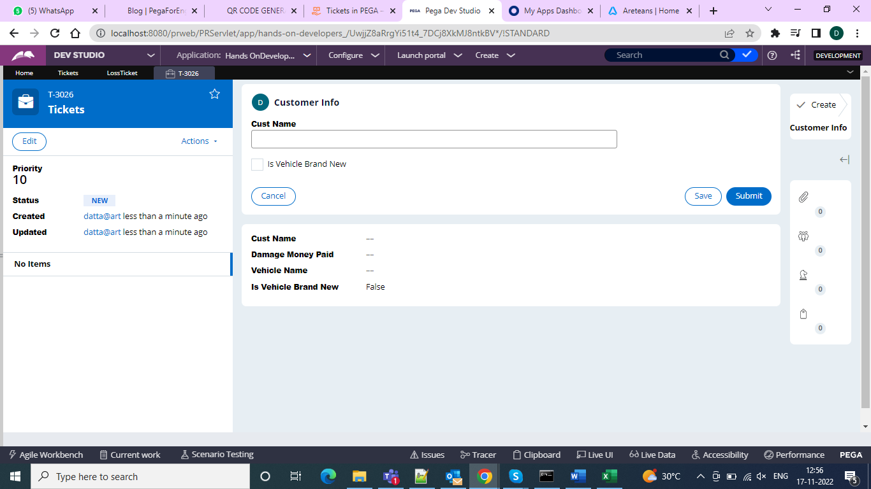

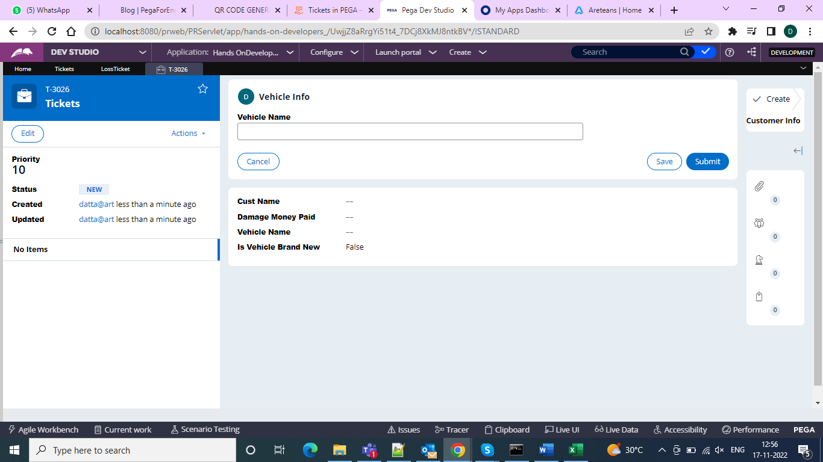

And if it is brand new should go to the loss details

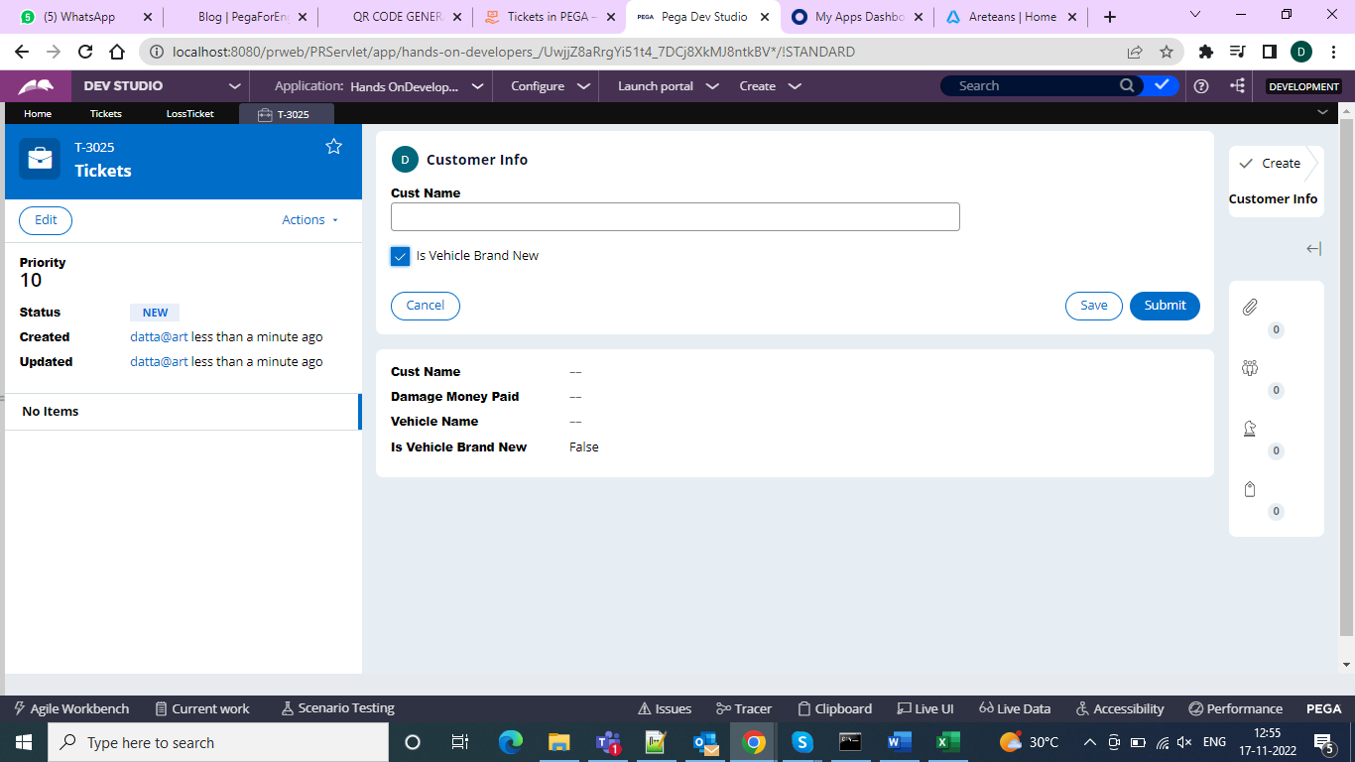

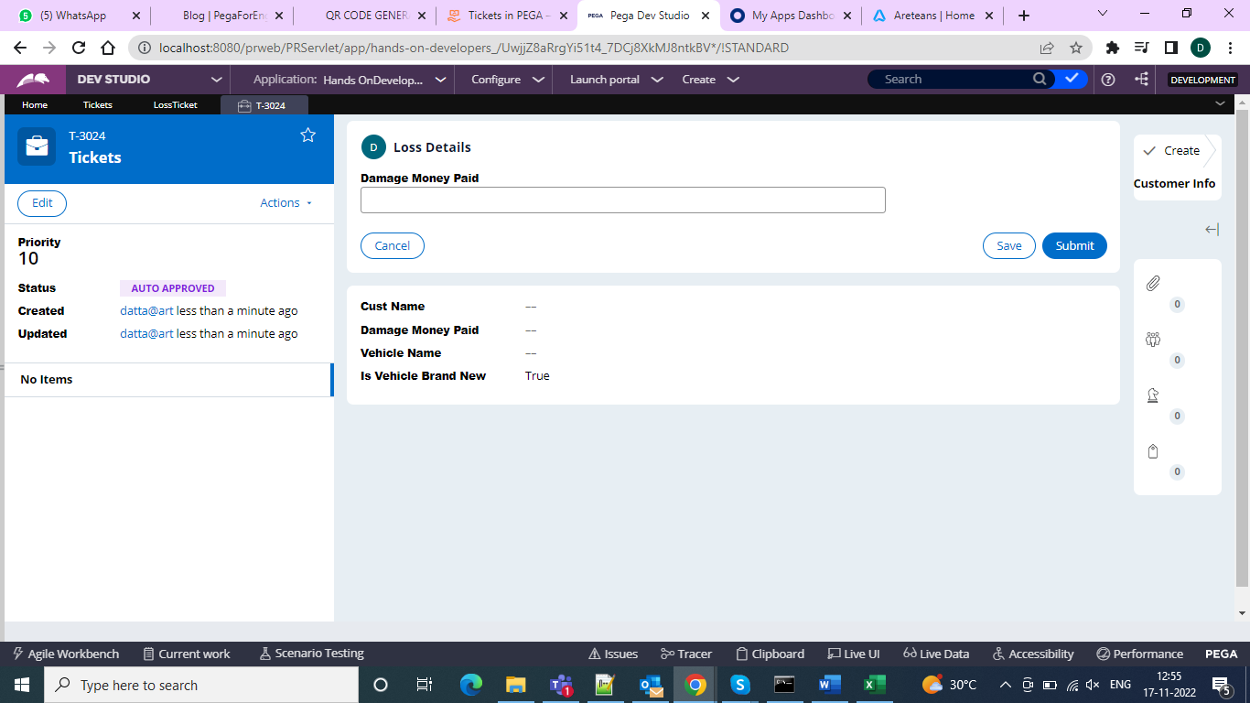

So instead of waiting for approval we can go for the tickets and do approvals instead of the SLA and wait time